Week 7
GRE 9277
Problems 81-90

81
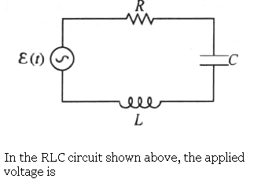

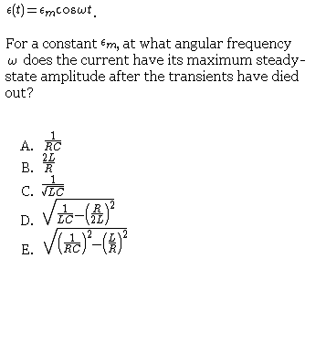
Resonance frequency (at which large amplitude builds up) is 1/sqrt(LC). Must know. You can write out Kirchhoffs loop rule, the differential equation, etc.

Answer C

82.

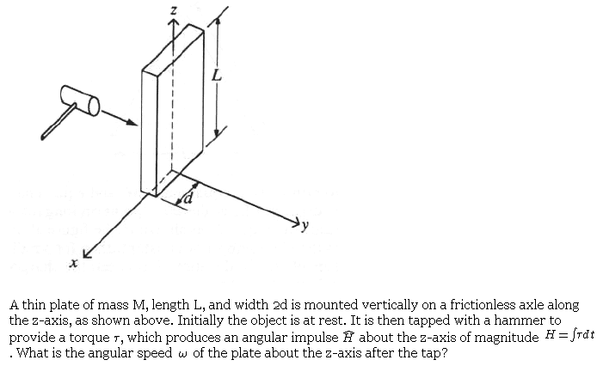
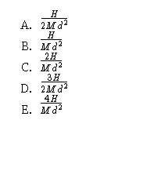

The impulse here should be called angular momentum “L”.

Rate of change of angular momentum=torque.

L=Torque*time.

L is given, Torque =I*alpha=I*change in omega /change in time.
So time cancels out.

Omega=L/I where for meter stick of length R moment of inertia =1/12(M*R^2) Here d is one half R. R=2d. So get 1/3 (Md^2). Answer D..

83
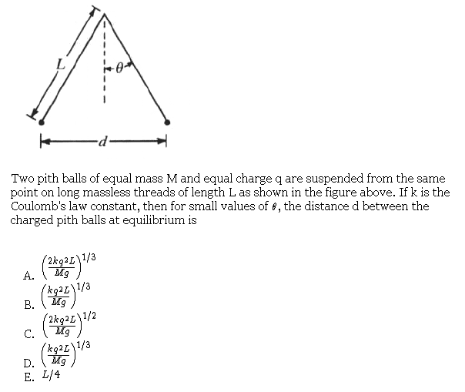

Vector addition.

Tcos(theta)-mg=0

Tsin(theta)=kqq/d^2.

Cos(theta)~1 and sin(theta)~(d/2)/L---solve for d. Answer A.

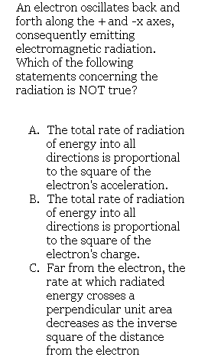

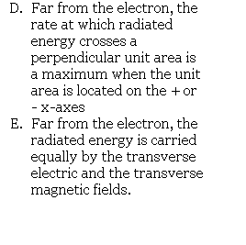

Must Know. Diple radiation is not emitted along axis of oscillation. Answer E.

85
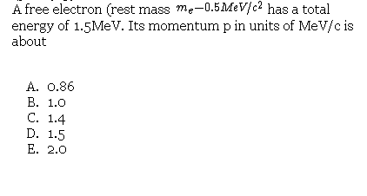

γmc^2=1.5(rest mass)c^2. Given gamma =3.

Solve for (v/c)=sqrt(8/9)

P=gamma*m*v

OR Use

E^2=(pc)^2+(mc^2)^2

Answer is C.

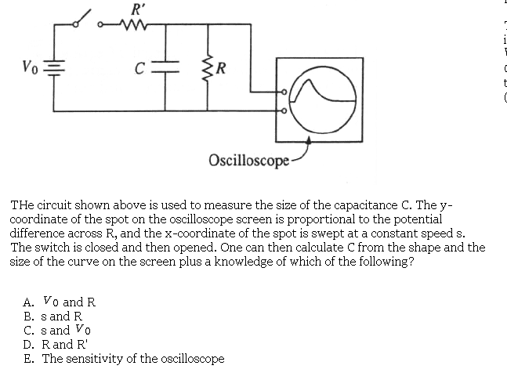

Really verbose. RC circuit----you need R and to know the time scale (sweep speed).
B.

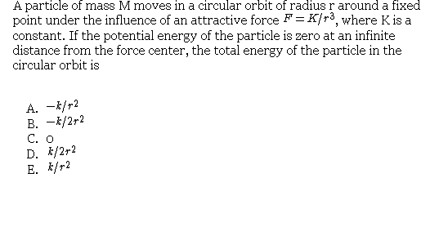

V=integral (-K/r^3)=-K/(2r^2) do the integral like in em, from infinity to r---over a primed variable.

Note the minus sign.

For any orbit mv^2/r=Force so here, KE=same as potential but positive. Energy total equal zero.

The answer is C. This is a strange case. The only bound state is equal to total energy of the free condition.

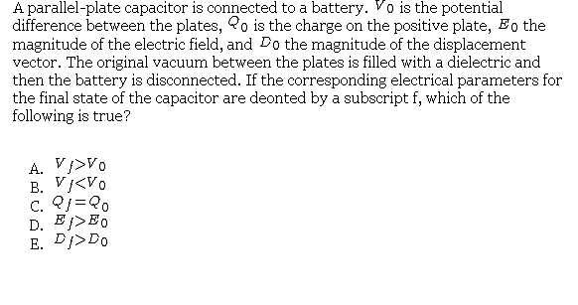

As the plate is filled with dielectric, then more charge “sucks” out of the battery and capacitance increases. The disconnect condition has voltage remain the same. Displacement field =dielectric, constant times E. Therefore the displacement field increases. Note the polarization effect tends to decrease the E field.

Answer E.

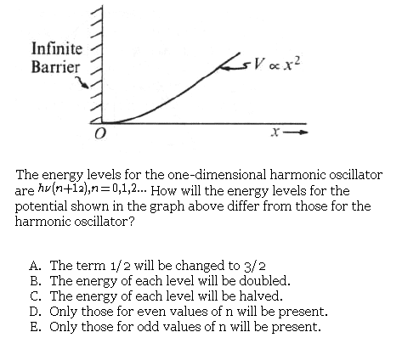

Harm osc states are waves with odd and even numbers of segments. The even label starts with ground state having a maximum in the center. The odd states have a node at the center. That satisfies current B.C. Omit all even states.

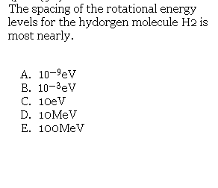

And the site answer is OK.

Quantum Mechanics}Rotational Energy Level
Rotational energy is related to angular momentum by . Quantum mechanics quantizes the angular momentum . Thus, .
The approximate spacing between two levels is given by .
The moment of inertia of is just that of two point-masses rotating about a center-point, thus , taking and (mass of proton). .
Now, . Plug everything in to get the right answer. . Converting J to eV, one has eV, as in choice (B).

